Lab Report No-09: Implementation of Priority Scheduling Algorithm

What is Priority Scheduling?
Priority Scheduling is a method of scheduling processes that is based on priority. In this algorithm, the scheduler selects the tasks to work as per the priority.
The processes with higher priority should be carried out first, whereas jobs with equal priorities are carried out on a round-robin or FCFS basis. Priority depends upon memory requirements, time requirements, etc.

Example of Priority Scheduling Algorithm
Consider the below table fo processes with their respective CPU burst times and the priorities.
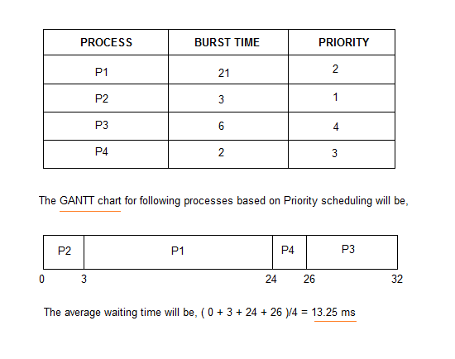

Implementing Priority Scheduling Algorithm in C++
Implementing priority scheduling algorithm is easy. All we have to do is to sort the processes based on their priority and CPU burst time, and then apply FCFS on it.
Here is the C++ code for priority scheduling algorithm:

#include<bits/stdc++.h>
using namespace std;
class process
{
public :
int id,burst_time,priority;
int turn_aroundtime,waiting_time;
};
bool compare(process p1,process p2)
{
return p1.priority < p2.priority;
}
void priority_sheduling(process p[],int n)
{
p[0].turn_aroundtime=p[0].burst_time;
for(int i=1;i<n;i++)
{
p[i].turn_aroundtime=p[i-1].turn_aroundtime+p[i].burst_time;
}
cout << "Turn around time : " ;
float sum1=0;
for(int i=0;i<n;i++)
{
cout << p[i].turn_aroundtime << " ";
sum1+=p[i].turn_aroundtime;
}
cout << "\nAverage turn around time : " << sum1/n << endl;
cout << "Waiting time : ";
float sum2=0;
for(int i=0;i<n;i++)
{
p[i].waiting_time=p[i].turn_aroundtime-p[i].burst_time;
cout << p[i].waiting_time << " ";
sum2+=p[i].waiting_time ;
}
cout << "\nAverage waiting time : " << sum2/n;
}
int main()
{
int n;
cout << "Enter the number of process : " ;
cin >> n;
process p[n];
for(int i=0;i<n;i++)
{
cout << "Enter process id , burst_time , priority : ";
cin >> p[i].id >> p[i].burst_time >> p[i].priority;
}
sort(p,p+n,compare);
cout << "Process id Burst_time Priority" << endl;
for(int i=0;i<n;i++)
cout << p[i].id << " " << p[i].burst_time << " " << p[i].priority << endl;
priority_sheduling(p,n);

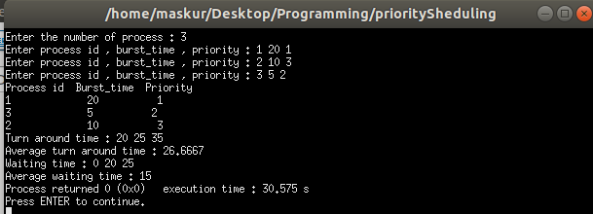
}

Summary:
- Priority scheduling is a method of scheduling processes that is based on priority. In this algorithm, the scheduler selects the tasks to work as per the priority.
- In Priority Preemptive Scheduling, the tasks are mostly assigned with their priorities.
- In Priority Non-preemptive scheduling method, the CPU has been allocated to a specific process.
- Processes are executed on the basis of priority so high priority does not need to wait for long which saves time
- If high priority processes take lots of CPU time, then the lower priority processes may starve and will be postponed for an indefinite time.

